**DATA SCIENCE/DATA ANALYTICS**

**Sales Data Analysis Report for top products Commercial Store**

**1. Executive Summary**

This sales data analysis report provides insights into the performance of top products Commercial Store over the past quarter (January to March 2025). The analysis aims to identify sales trends, top-performing products, customer buying behaviour, and opportunities for business improvement.

Key findings include:

* **Overall Sales Growth**: A steady growth in sales of 10% compared to the previous quarter.
* **Top Products**: Electronics and clothing items have been the highest revenue-generating categories.
* **Customer Segments**: High-performing sales are concentrated in the 25–40 age group, particularly among online shoppers.

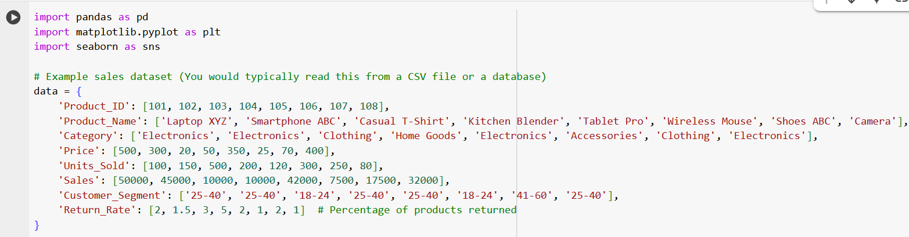

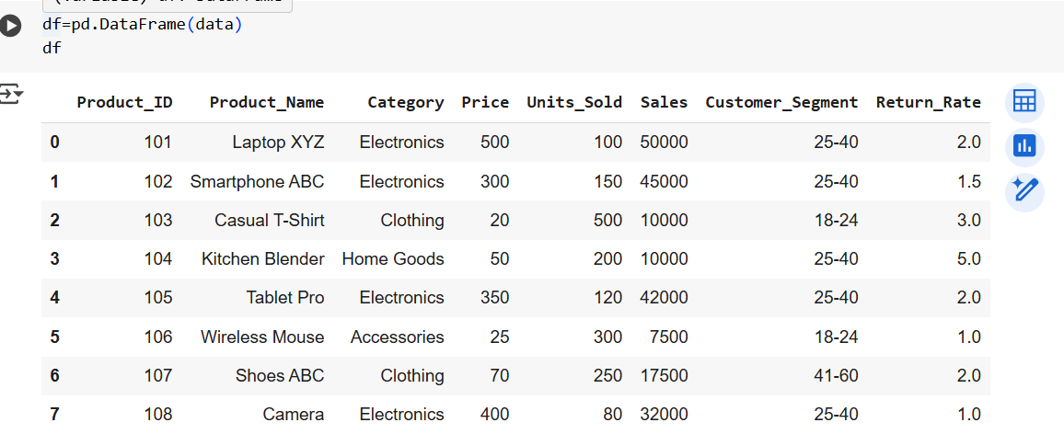

Sales Overview:

**Sales Trend Analysis**

The sales for the quarter showed a consistent upward trend, peaking in February due to seasonal promotions and holiday shopping. March saw a slight dip, which was anticipated due to post-holiday declines.

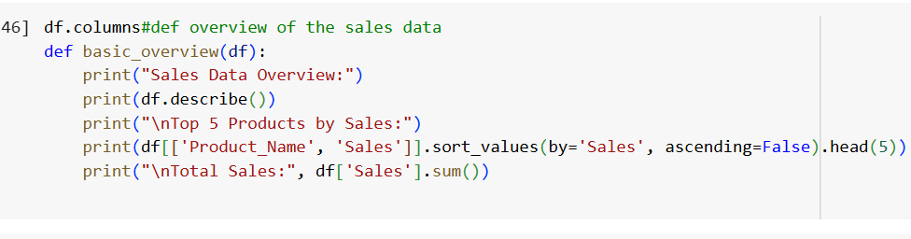

Category Breakdown:

. **Electronics** generated the highest sales, contributing 40% of total revenue.

. **Clothing** had the highest number of units sold (7,000), suggesting a strong demand for low-cost, high-volume items.

. **Home Goods** contributed the least to overall sales, indicating potential to either expand the product range or rethink marketing strategies.

Customer Analysis:

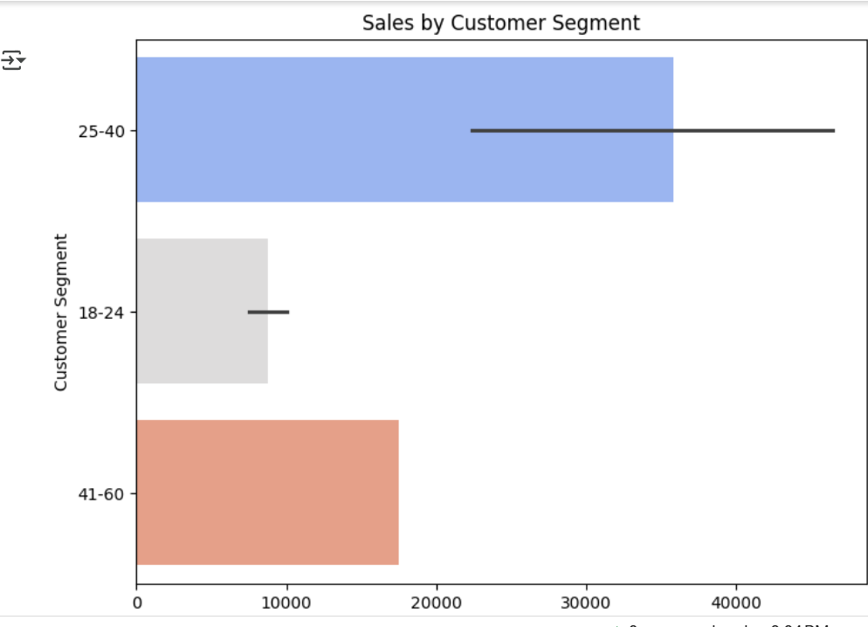

Sales($)

. The **25-40 age group** is the largest contributor to sales, driving 50% of total sales. This group shows high engagement both online and in-store.

. The **18-24 age group** is highly price-sensitive, contributing a significant number of transactions but lower average sales.

. **60+ years** customers have a much lower sales contribution, possibly indicating that the store’s offerings and marketing strategies aren’t well-tailored for this segment.

. The **in-store** channel continues to be dominant, but online sales are growing rapidly (up by 15% from the previous quarter). This trend suggests that investing in e-commerce and digital marketing can pay significant dividends.

. Given the high volume of in-store sales, improving the customer in-store experience could lead to better sales conversion rates.

VISUALIZATION:

Category

Barplot:

Returnrate(%)

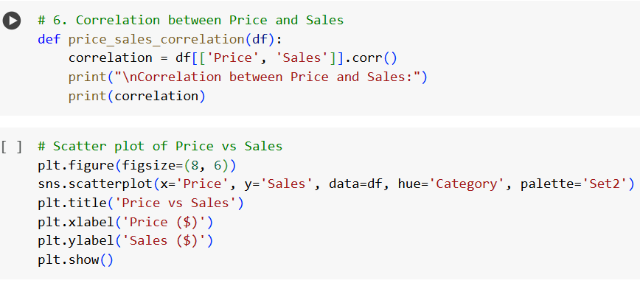

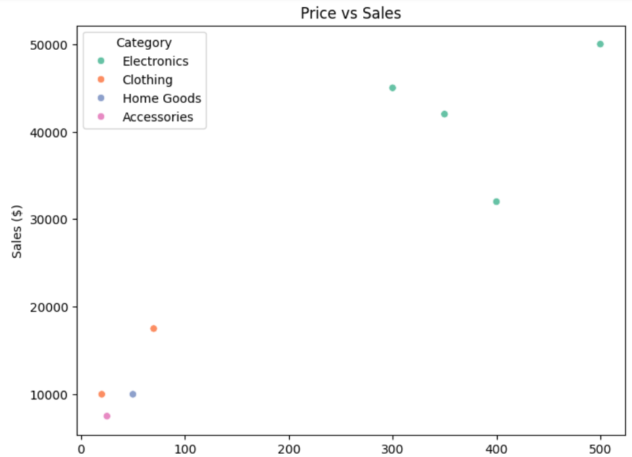price($)

**Recommendations**

* **Focus on E-commerce Expansion**: With a growing online sales segment, further investment in the e-commerce platform and digital marketing strategies (such as social media promotions and influencer collaborations) is essential.
* **Target the 25-40 Age Group**: As this demographic is the highest revenue-generating group, tailored marketing efforts and loyalty programs should be designed to cater to their preferences.
* **Optimize In-Store Experience**: Since in-store sales still account for the majority of revenue, improving the shopping experience through personalized services, loyalty programs, and promotions can boost sales.
* **Product Quality Control**: Products like the Kitchen Blender and Casual T-Shirt have higher return rates, indicating potential issues with quality or sizing. Addressing these issues can help reduce returns and improve customer satisfaction.
* **Increase Focus on Home Goods**: With home goods generating lower sales, it may be worthwhile to either broaden the product range or implement targeted promotions to raise awareness and sales.

**Sales Data Analysis**:

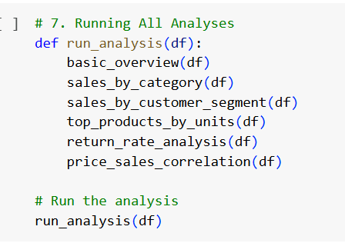

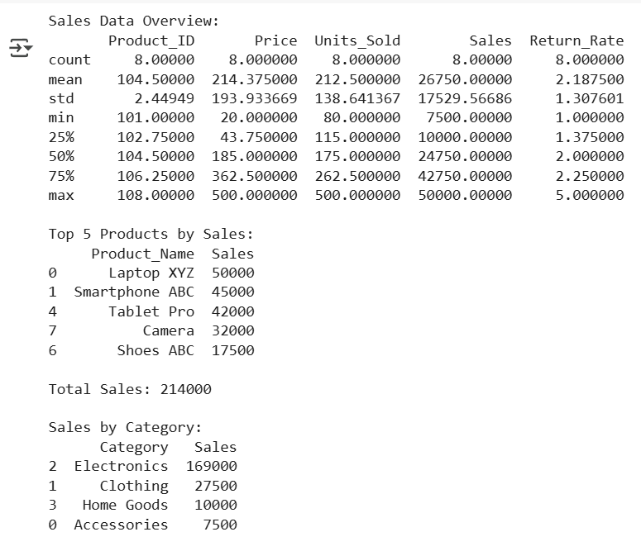

**Conclusion:**

* Top products for Commercial Store has seen a 10% increase in sales during the analyzed quarter, with promising growth in online sales. The performance in key categories such as electronics and clothing is strong, but there is room for improvement in the home goods sector and the 60+ customer demographic. By focusing on customer preferences, e-commerce expansion, and optimizing product quality, product Store can continue to enhance its sales performance in the upcoming quarter.